# AREA AGENCY ON AGING OF WESTERN MICHIGAN

**­­­­­BOARD OF DIRECTORS**

**ANNUAL MEETING MINUTES**

**April 28th, 2025**

3215 Eaglecrest Dr. NE, Grand Rapids MI 49525

**UNIT OF GOVERNMENT MEMBERS PRESENT MEMBERS ABSENT**

ALLEGAN COUNTY Mark DeYoung

Mary Campbell

GRAND RAPIDS, CITY Lisa Knight

Jane DeVries

IONIA COUNTY Larry Tiejema

Edna Albert

KENT COUNTY Carol Hennessy

Nancy Nielsen

LAKE COUNTY Marilyn Burns

Kristine Raymond

MASON COUNTY Ron Bacon

MECOSTA COUNTY Bill Routley

Sharon Bongard

MONTCALM COUNTY Nathan Alexander

Chuck Hazekamp

NEWAYGO COUNTY Lori Tubbergen-Clark

Richard Fitzpatrick

OSCEOLA COUNTY Russ Nehmer

Dawn Montague

**Staff Present:** Kendrick Heinlein, Scott Russett, Holly Williams, Cassie Caple, Laura Dobrzelewski, Margie Pettit, Ashley Schwartz, Chris Liscombe, Jessica Torpey

**Guests:** Ashley Ellsworth – Health & Aging Services Agency; Barb Hazlett – AAAWM Advisory Council Chairperson

1. **Roll Call and Agenda Approval**

Chair Bill Routley called the meeting to order at 1:30 pm. A quorum was present.

Dawn Montague moved, and Ron Bacon seconded the motion to approve the agenda. Motion carried.

1. **Minutes of the April 22, 2024 Meeting**

Ron Bacon moved and Dawn Montague seconded the motion to approve the April 22, 2024 minutes. Motion carried.

1. **Reports**
   1. **Report of Nominating Committee**

Ron Bacon, expressed the nominating committee feels confident in putting forth the following candidates to the Executive Committee for the next term of the AAAWM Board of Directors:

Chairperson: Bill Routley

Vice Chairperson: Carol Hennessy

Treasurer: Chuck Hazekamp

Secretary: Ron Bacon

Member-at-Large: Nancy Nielsen

Member-at-Large: Marilyn Burns

There were no other nominations from the Board of Directors.

**Action Item:** Dawn Montague moved to elect the above candidates to the Executive Committee for the AAAWM BOD, Barb Hazlett seconded the motion. Motion carried.

* 1. **Old Business:** None.
  2. **New Business:** None.

**IV. Other**

1. **Public Comment:** None.
2. **Next Meeting Date:** Chair Bill Routley stated the next Board of Directors Annual Meeting will be on April 27, 2026. The meeting adjourned at 1:35 p.m.

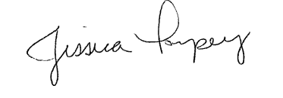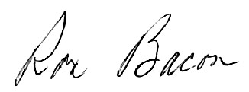

___________________________ ______________________________

Jessica Torpey, Recorder Ron Bacon, Secretary