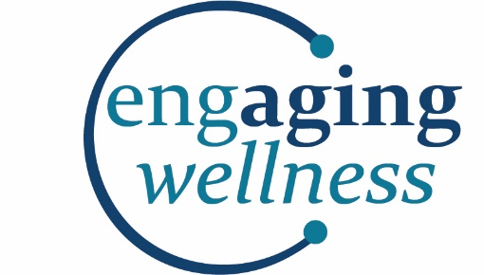

A Matter of Balance: Managing Concerns About Falls
Coach Application

Date:

Name:
Address:

Phone: E-mail:

Name of Agency Affiliation, if any
Staff Volunteer
Best way to contact me:

Emergency Contact Name:
Emergency Contact Phone:

Gender: Female Male
Education:
Some high school High school graduate

Some college or vocational school College graduate
Some graduate school Graduate school

Occupation or life experience:

Hobbies and activities enjoyed:

Other volunteer experiences:

Please complete page 2

Coach Application Page 2

Circle your Age group: Less than 50 yrs 50-54 yrs 55-59 yrs
60-64 yrs 65-69 yrs 70-74 yrs
75-79 yrs 80-85 yrs Over 85 yrs

Do you speak more than one language? Yes No
If yes, what language(s):

Do you have transportation? Yes No

How did you hear about a Matter of Balance?
Flyer Newspaper Word of mouth Presentation
Other

Why are you interested in becoming a Matter of Balance coach?

My Basic Availability:
I would be available for sessions held:
Monday Tuesday Wednesday Thursday Friday

Best time of day: (2 hour sessions)
Mornings Afternoons
Not sure – please call me when you are scheduling a class

Best Location for me is:

I agree to co-facilitate two (2) A Matter of Balance Workshops within one (1) year of my
Certification, one (1) of which must be a community workshop through the Area Agency on Aging of Western Michigan AND attend the Annual Coach Update Meeting.

Signature Date

You will receive a confirmation email when your application has been processed

